Skills Workshop #8: Technical Writing and Presentation Workshop
Speaker: Dr. Anant Kukreti, Director for Engineering Outreach for the College of Engineering and Applied Science, Professor in Department of Biomedical, Chemical and Environmental Engineering
Date: Wednesday, June 21, 2017
Time: 10:00 – 11:30am
Venue: University of Cincinnati, Rhodes Hall, Room 413

Prepared by:
Tiara Anderson, Purcell Marian High School, Cincinnati, Ohio
RET Participant for Project #2: Energy Storage Devices Based on Three Dimensional (3D) Graphene: Case Supercapacitors and Lithium- Sulfur (Li-S) Batteries

This session was given by Dr. Anant Kukreti, Director for Engineering Outreach for the College of Engineering and Applied Science and Professor in the Department of Biomedical, Chemical and Environmental Engineering on Wednesday, June 21, 2017 from 10:00 – 11:30am at the University of Cincinnati in Rhodes Hall, Room 413. The session provided RET participants with information about the components of the RET Research Report (or Technical Paper) and the National Science Foundation (NSF) Summary Report along with specific instructions on how to create quality reports. Dr. Kukreti began by informing participants that the technical reports have strict, rigid formatting guidelines that must be followed and encouraged us to think of our research as a part of a world-wide conversation among scientific peers. Participants were given handouts as helpful resources at the start of the presentation (Figure 1). It is apparent that Dr. Kukreti is well informed on the session topic as he has much experience in both writing and reviewing technical reports as a professor and the current manager of several major NSF grants.

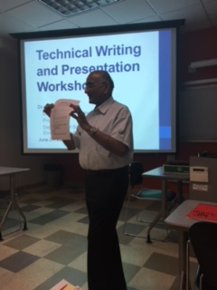
Figure 1: Dr. Kukreti referring to the General Guidelines of Technical Writing Handout

Dr. Kukreti first focused on the RET Research Report (or Technical Paper) and reviewed its components extensively. The report consists of a cover page, abstract, key words, and the main body, which is the largest component. Dr. Kukreti explained that the contents of the main body have a natural flow starting with the introduction. The introduction is a broad overview of the research topic and its importance to society. The report would then proceed to the literature review, where the writer provides readers with the current research status of the topic and also addresses the issues that are yet to be resolved. Dr. Kukreti referred to these challenges as “missing links” in the research. Naturally, the goals and objectives section follows and tells which missing links the report seeks to address. The research details section is following, extensively describing methods the researcher used to address the missing links. The research results are finally reported as raw data and the writer then interprets the data in the conclusions section. The writer makes recommendations to further the research, gives acknowledgements and then references all sources in a bibliography. There may be several appendices to further explain topics mentioned in the main body of the paper. In the report, RET teachers will also have to include a narrative of how their research will be linked to the RET Unit they will teach in the upcoming school year.

After reviewing the contents of the Research Report and special formatting guidelines, Dr. Kukreti shared helpful tips to facilitate the process of writing the technical paper. First, it is important to spend ample time prewriting and rewriting the report. Figure 2 shows a pie chart displaying the relative percentage of time that should be spent on each stage of writing the report. Most time should be dedicated to prewriting when the writer collects, synthesizes and organizes information. Writers are encouraged to do prewriting away from the computer. When rewriting, read one’s work aloud, cutting any unnecessary clutter and checking verbs. It is also important to get feedback during this stage. Finally, the last 10 percent is writing a first draft. Be sure that the draft follows formatting guidelines so that the reviewer may focus on the content of the paper rather than correcting formatting errors.

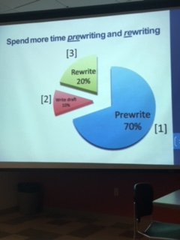
Figure 2: Plan for writing research report

After giving helpful tips for the report as a whole, Dr. Kukreti shared sentence level tips to encourage academic tone and strong sentence structure. He encouraged writers to use active voice, chose strong and specific verbs and to cut unnecessary words. He also encouraged writers to avoid turning verbs into nouns, jargon and use of abbreviations, burying the main verb and to use the words “we” and “I” sparingly. In Figure 3, RET participants are discussing how to change a given sentence from passive voice to active voice. Following the exercises, Dr. Kukreti shared how to write a quality abstract, a naturally flowing paragraph, and how to cite figures, tables and graphs appropriately. Participants must use ASCE (American Society for Civil Engineers) format for citations included in the bibliography.

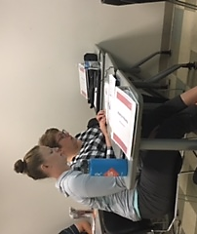
Figure 3: Practice changing passive voice to active voice

Finally, Dr. Kukreti reviewed the National Science Foundation Summary Report Contents. The Summary Report serves as a short version of the Research Report with similar contents but different formatting. The NSF Summary Report also requires four high resolution action photographs with captions. The main body of the report consists of goals and objectives, literature review, research tasks, methodology, research training, research findings and classroom implementation plans of each teacher assigned to the project. At the conclusion of the workshop, Dr. Kukreti shared other resources RET participants can use to find more information on how to write a quality technical paper.

